Writing Memoir: From Free Write to Manuscript

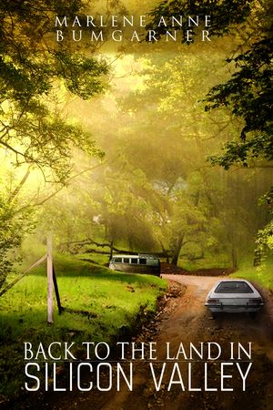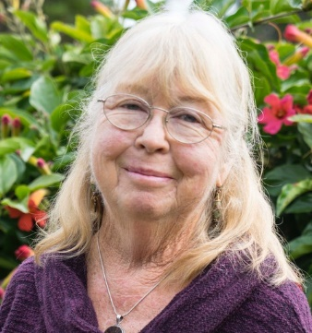

Village Santa Cruz County member Marlene Anne Bumgarner, author of Back to the Land in Silicon Valley, recently presented to our Writing Group, strategies on writing about our lives.
The presentation was very informative and I asked Marlene if she’d be willing to share her ideas and process in our newsletter, for those who missed the presentation.
from Marlene: ‘Mary Howe asked me to share some of the elements of our Zoom memoir-writing workshop last week. Here, in a nutshell, is my presentation:
- Dedicate a journal just for memoir – lines for writing; blank pages for sketching and mind-mapping
- Start anywhere in your life – tell a story just like you would for a grandchild
- Free-write first – don’t censor yourself – then write for an hour
- The physical process of writing connects your hand directly with your creative brain.
- Once you have a collection of stories, begin to organize them
- What is your theme? (Coming of age; Dealing with loss; Determination; Discrimination; Friendship)
- Develop a story arc – study fiction -- write like a novelist
- Decide on structure – chronological or thematic; stream of consciousness
- NOW you can think about your audience, research details, start to muse a bit
Five Elements of an Effective Memoir
- A focused theme. Identify an overarching theme, takeaway lesson, or message for your readers, and thread it through all the stories
- Conflict. ...We all like a bad guy
- A personal writing style. ... use supporting stories and details to bring your stories to life
- Use storytelling elements. ... First person, memory, musing, defining moments
- Tell the truth – memory is fallible – do your research, check with others who were there
For more ideas about writing memoir, visit my blog at http://www.marlenebumgarner.com after Nov 1.’

